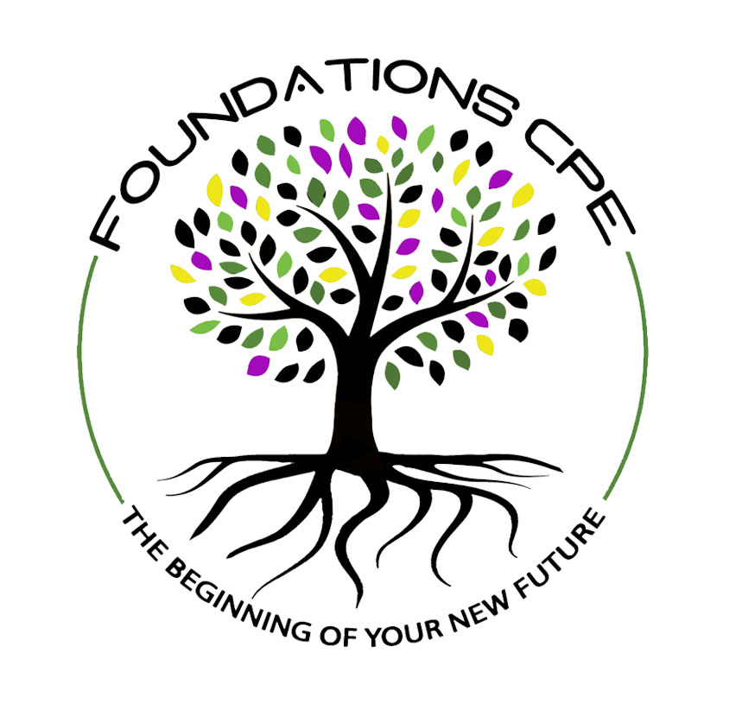

FOUNDATIONS CPE CENTER, LLC

RELEASE OF INFORMATION REQUEST

I understand that information regarding my participation in the Clinical Pastoral Education (CPE) program at Foundations CPE Center, LLC will not be released to anyone without my written permission, except as required by law.

This includes all official records, except material that is normally reported to the ACPE National Office. No evaluation(s) will be shared with anyone without my written permission.

I authorize the Clinical Pastoral Education Educator(s) at the Foundations CPE Center, LLC, 104 E. Ovilla Rd, PO Box 219, Red Oak TX 75154-9998 to release my CPE evaluation and other material as indicated, to the following:

___________________________________________

___________________________________________

___________________________________________

___________________________________________

___________________________ _________________
Student Signature Date

___________________________ _________________
ACPE Certified Educator Signature Date

