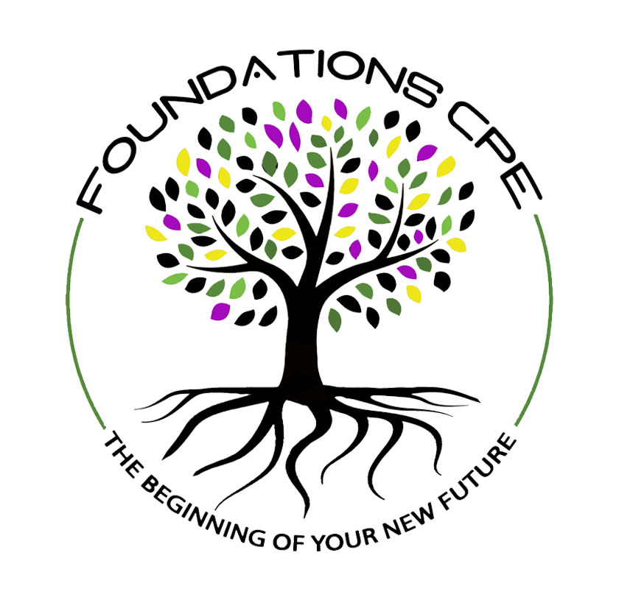
EDUCATIONAL AGREEMENT FOR TRAINING
for
FOUNDATIONS CPE CENTER, LLC
CLINICAL PASTORAL EDUCATION

CPE is conducted as an “education for ministry experience.” This document and acceptance into Foundations CPE Center, LLC at Clinical Site Name:____________________________________ authorize me to participate fully in community programs and to visit patients as a chaplain intern, chaplain resident, or certified education student/candidate, to be informed of their situation (physically, spiritually, emotionally, psychologically, and sociologically), and to write materials related to my visits that would be beneficial to my educational process under the supervision of an assigned ACPE Certified Educator.

I will maintain confidentiality with respect to protected health information and I understand that any communication regarding patients or care receivers outside the professional treatment and/or training circles is prohibited, except as required for the safety of patients, families, team members, or others. Breach of this standard of professional confidentiality and/or any of the AAH Policies and Procedures as determined by the hospital management may result in my immediate termination.

I understand that some portions or all of my clinical experience and my educational activities may take place via video conferencing or audio conferencing. I am aware of the ACPE educational standard that group supervision takes place synchronously. I have access to the necessary equipment to participate effectively in videoconferencing. I will maintain confidentiality during video or audio conferencing by using a dedicated, distraction-free space. I will not record any portion of group or individual supervision without the authorization of all participants in the conversation.

I understand that my name, address, and other contact information may be kept in a database for mailings and references concerning future Foundations CPE Center, LLC communications. This list will only be available for Foundations CPE Center, LLC, and will not be distributed or sold. I understand that I may, at any time, submit a written request to have my information removed from the database.

Foundations CPE Center, LLC is accredited for Level 1A and 1B, Level 2A and 2B CPE with ACPE. When I receive the System and Site CPE Handbooks, System and Site policies, including the Financial, and Dismissal and Withdrawal policies, and the ACPE Standards governing clinical pastoral education, I will review them.
In all activities during my clinical pastoral education program, I agree to function professionally and within the Code of Professional Ethics as contained in Foundations CPE Center, LLC Code of Ethical Conduct and the Foundations CPE Center, LLC CPE Code of Professional Ethics for CPE Student which is consistent with ACPE Standards. I have been shown how to access the ACPE Standards containing the Code of Professional Ethics and reviewed it during my orientation.

I understand that my education records at Foundations CPE Center, LLC include a copy of my final evaluation, my Certified Educator’s final evaluation, the face sheet of my application, this training agreement, and the Use of Clinical Materials Consent Form. My evaluations will be maintained for 10 years at Foundations CPE Center, LLC, and the other documents will be kept indefinitely. I understand that Foundations CPE Center, LLC guarantees me the right to inspect and review education records, to seek to amend them, to specified control over the release of record information, and to file a complaint against the program for alleged violations of these Family Education Rights and Privacy Act (FERPA) rights. I have the right to object to the content of my educational record. If a resolution is not negotiable, my written objection will be kept and released with my educational record. Assessment of my demonstration at the ACPE outcomes is exempted from this right.

Violations of this protocol may be reported to the Chair of the Accreditation Commission at:

ACPE: The Standard for Spiritual Care and Education
1 Concourse Pkwy, Suite 800
Atlanta, GA 30328
(404) 320-1472

I understand and agree to the conditions of this Agreement for Training.

____________________________________________________________________________

Signature of CPE Student/CEC Student Date Printed name

____________________________________________________________________________
Start and End Dates of the Unit

